Red Ant Media LLP

Technical Assessment

Name: Indhu Sree S

Roll no: 1832023

M.Sc Data Science

Question: 03

**Cathy works as an editor in a magazine. She is responsible for the games and puzzles section in the magazine. But unfortunately, she doesn’t have time to go about creating a puzzle on her own every month. Help her by creating a sudoku validator.**

1. **It will be a standard 9 X 9 sudoku board**
2. **Each row must contain the digits 1-9 without repetition.**
3. **Each column must contain the digits 1-9 without repetition.**
4. **Each of the nine 3 x 3 sub-boxes of the grid must contain the digits 1-9 without repetition.**
5. **Provide an interface where there will be an empty board.**
6. **Cathy can type in the squares that she wants with numbers that she wants to.**
7. **When she clicks on validate, the solution should tell her whether the partially entered board by her is a valid sudoku board or not**

Language Used: **Python**

* To Print like a Sudoku Board

Code:

def print_board(board):

'''Prints the board'''

boardString = ""

for i in range(9):

for j in range(9):

boardString += str(board[i][j]) + " "

if (j+1)%3 == 0 and j != 0 and (j+1) != 9:

boardString += "| "

if j == 8:

boardString += "\n"

if j == 8 and (i+1)%3 == 0 and (i+1) != 9:

boardString += "- - - - - - - - - - - \n"

print(boardString)

* To Find an empty cell and returns its position as a tuple

Code:

def find_empty (board):

for i in range (9):

for j in range (9):

if board[i][j] == 0:

return i,j

* Whether a number is valid in that cell, returns a bool

Code:

def valid(board, pos, num):

'''Whether a number is valid in that cell, returns a bool'''

for i in range(9):

if board[i][pos[1]] == num and (i, pos[1]) != pos: #make sure it isn't the same number we're checking for by comparing coords

return False

for j in range(9):

if board[pos[0]][j] == num and (pos[0], j) != pos: #Same row but not same number

return False

start_i = pos[0] - pos[0] % 3 #ex. 5-5%3 = 3 and thats where the grid starts

start_j = pos[1] - pos[1] % 3

for i in range(3):

for j in range(3): #adds i and j as needed to go from start of grid to where we need to be

if board[start_i + i][start_j + j] == num and (start_i + i, start_j + j) != pos:

return False

return True

* Solves the Sudoku board via the backtracking algorithm

Code:

def solve(board):

'''Solves the Sudoku board via the backtracking algorithm'''

empty = find_empty(board)

if not empty: #no empty spots are left so the board is solved

return True

for nums in range(9):

if valid(board, empty,nums+1):

board[empty[0]][empty[1]] = nums+1

if solve(board): #recursive step

return True

board[empty[0]][empty[1]] = 0 #this number is wrong so we set it back to 0

return False

**Work Flow:**

* Creating a Sudoku Board
* Print a Sudoku Board
* Checking for a Correct Answer

Code:

if __name__ == '__main__':

board = [

[0, 0, 0, 0, 0, 0, 0, 0, 0],

[0, 0, 0, 0, 0, 0, 0, 0, 0],

[0, 0, 0, 0, 0, 0, 0, 0, 0],

[0, 0, 0, 0, 0, 0, 0, 0, 0],

[0, 0, 0, 0, 0, 0, 0, 0, 0],

[0, 0, 0, 0, 0, 0, 0, 0, 0],

[0, 0, 0, 0, 0, 0, 0, 0, 0],

[0, 0, 0, 0, 0, 0, 0, 0, 0],

[0, 0, 0, 0, 0, 0, 0, 0, 0]

]

ch1 = 'y'

while(ch1 == 'y'):

print("Enter Your Choice ")

print("1. Creating A Sudoku Board ")

print("2. Print A Board")

print("3. Check for Answer")

ch = int(input('[1/2/3] : '))

if(ch == 1):

#Cathy Input Board

number = int(input("Enter the no of input numbers : "))

for i in range(number):

row = int(input('Enter Row No. to change :'))

column = int(input('Enter Column No. to change :'))

board[row][column] = int(input('Enter the new number : '))

print_board(board)

elif(ch == 2):

print_board(board)

else:

solve(board)

print_board(board)

ch1 = input('Do you want to Continue [y/n] : ')

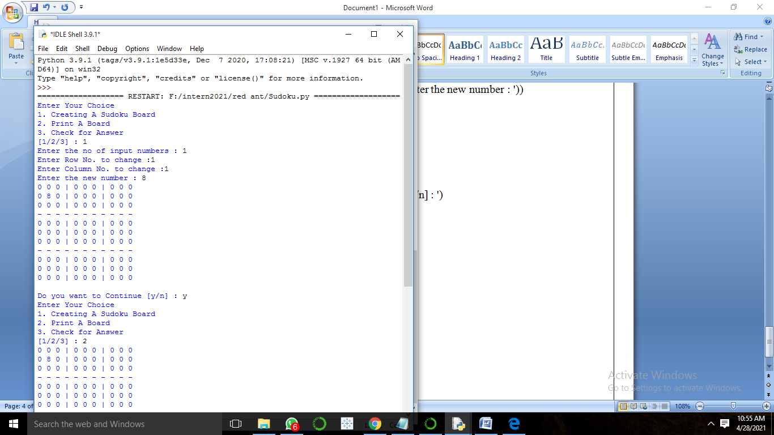

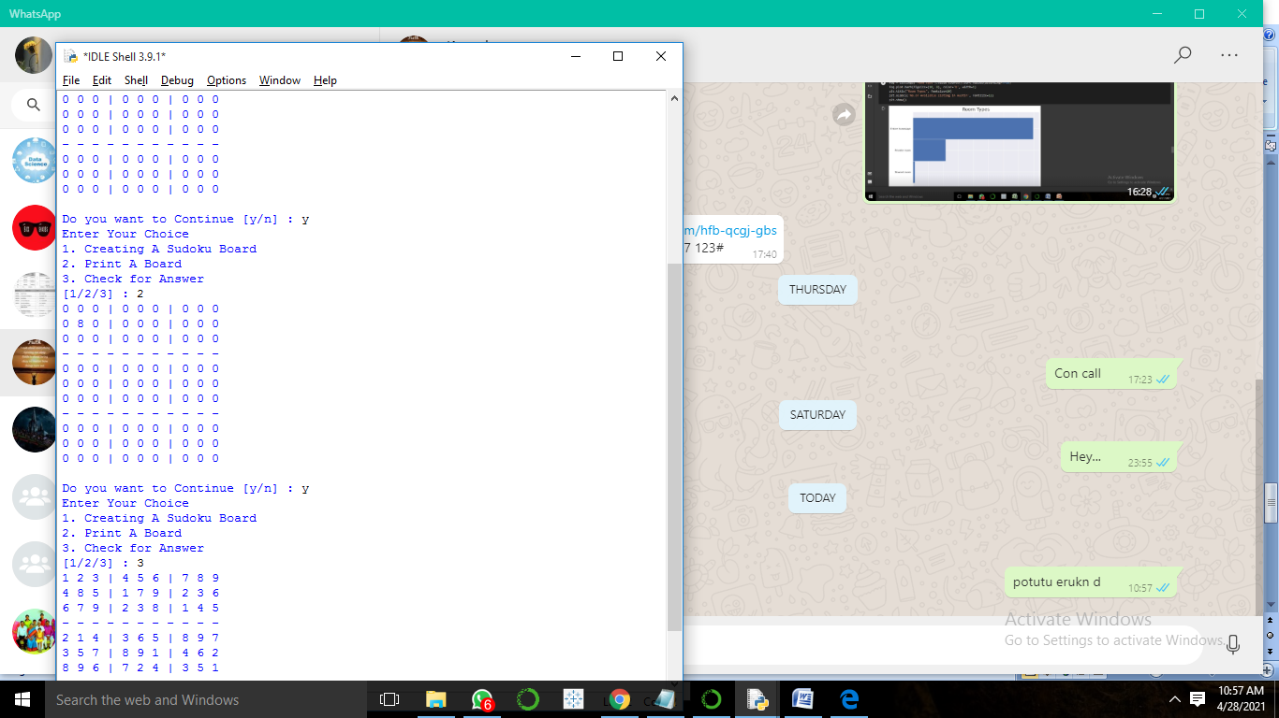

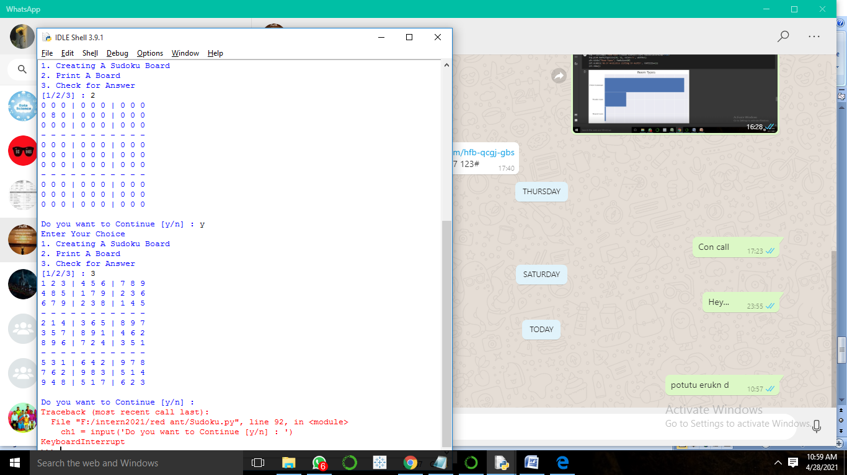

**Conclusion:**

Here I created my own Sudoku Board and printed the result of the Sudoku board with help of some conditions. Each row must contain the digits 1-9 without repetition. Each column must contain the digits 1-9 without repetition. Each of the nine 3 x 3 sub-boxes of the grid must contain the digits 1-9 without repetition. I hope, It will help Cathy for her work.